**UNIVERSITY OF WATERLOO**

Faculty of Mathematics

**The effects of open-office plan and methods to maximize productivity in an open office**

Camis Inc.,

Guelph, Ontario

Phat Tran

20619470

1B Mathematics

December 2016

Table of Contents

List of Figures 2

Executive summary 3

Introduction 4

What is an open-office plan? 5

history of open concept 5

implementation of an open-office plan 5

Pros and cons of an open office 7

advantages 7

disadvantages 7

overall effect 7

How to be productive in an open office? 8

implement a daily undistracted work hours 8

pack all communication in one block of time 8

give way to distraction 8

Conclusion 9

References 10

# List of Figures

Figure 1 - The Typical Open Office 5

Figure 2 - The World's Largest Open Office 5

Figure 3 - Mark Zuckerberg at his Workstation 5

Figure 4 - Camis Headquarter 6

# Executive summary

This report attempts to analyze the overall effect of an open-concept office by considering its advantages and its disadvantages. In the last section of the analysis, it shows the possible strategies to overcome the negative effects and maximizes the benefits of an open office.

# Introduction

In the recent years, there has been a rising trend of breaking down walls in office in order to maximize the communication flow within the office. It has been implemented by a lot of tech startups in a Silicon Valley and widespread application does not seem to slow down. Thus, there is a need for an analysis on the impact of implementing open concept in a workplace.

With that being mentioned, in this report, the main issue that is being dissected is the effect of having an open-concept office. Therefore, it is assumed that readers have a basic understanding of open-office concept, but as a refresh, general definition and examples will be given. There will be an in-depth analysis between the advantages and disadvantages of such plan, and thus, leading to a better awareness of the work environment and take full advantage to enhance our productivity.

# What is an open-office plan?

## introduction of open concept

This concept was carried out in the 1950s by a team in Hamburg, Germany (Faustman, 2013). According to Matt, (2013) the main rationality behind an open concept office is to “facilitate communication and the flow of ideas”. In the recent years, many technology companies have been taking advantage of this concept. Facebook and Square are two of many examples that have executed on this idea in their headquarters (Newport, 2016). Lesser known software companies such as Camis Inc. located in Guelph, Ontario also have an open-office headquarter, but in a slightly different variation.

## implementation of an open-office plan

When one mention “open-office plan”, it is typical for one to imagine such application to resemble this:

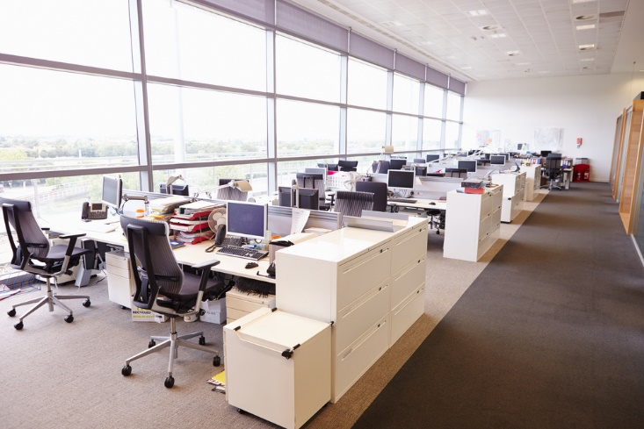

Figure 1 - The Typical Open Office

There are many other variations. Some are more open:

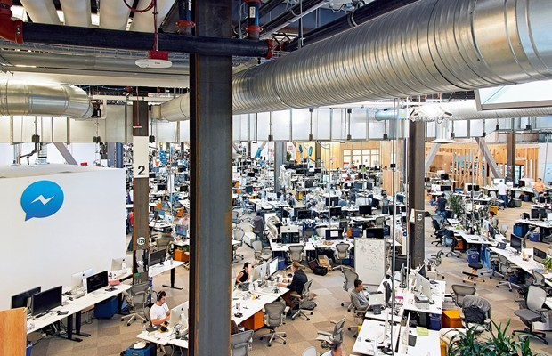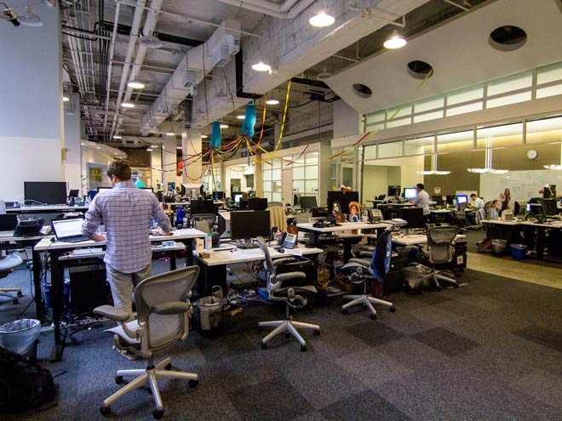

Figure 2 - The World's Largest Open Office

Figure 3 - Mark Zuckerberg at his Workstation

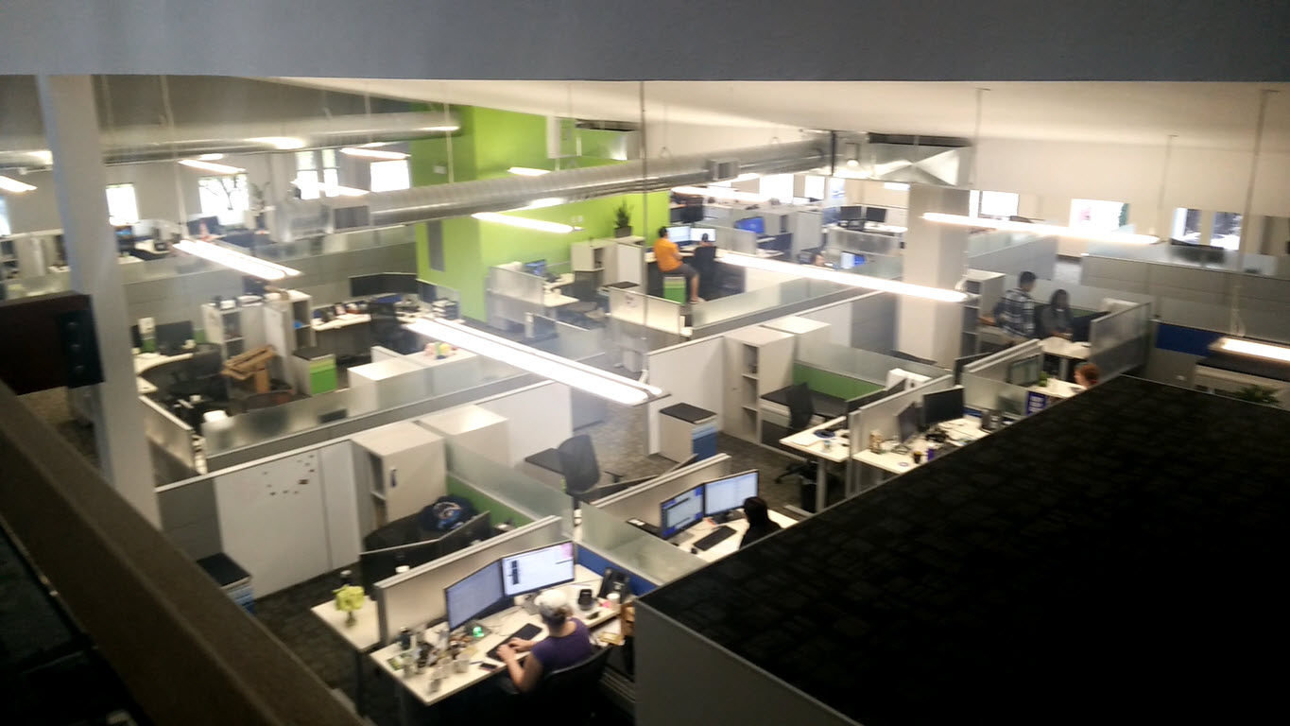While others are more traditional and have some more privacy between workspaces:

Figure 4 - Camis Headquarter

# Pros and cons of an open office

## advantages

The main and most important reason why a software company should consider implementing an open-office plan is to encourage serendipitous interaction among workers. Not only would it greatly expedite communication process between employees, the fact that it is so easy to talk to your teammates also improves team chemistry. Thus, it would improve teams’ productivities and even potentially foster new innovative ideas.

Another benefit of open design is that it provides an invisible accountability in the work environment, since everyone can walk by and see one’s work without a moment notice. This would inadvertently keep employees from working on personal issues using the company’s resource, therefore, saving company’s resource in the long run.

Last but not least, having no walls in between offices can greatly reduce the cost of building an office. Even though this might not be a significant benefit to enormous corporations, it’s impact is quite profound on small businesses and software companies. This extra savings in resource could be reallocated and used elsewhere to further grow the company.

## disadvantages

Due to the nature of open office, the noise level can vary and becoming incontrollable for everyone. Because of that, open-office floorplan can be extremely distracting for one to focus. According to Maria (2014), it is “damaging to the workers’ attention spans”, thus, lowering workers’ concentrating ability and motivation.

The transparency of the office creates a subtle pressure of being watched constantly; therefore, forcing employees to focus on work-related tasks. This pressure, inadvertently, raises one’s epinephrine level which causes their anxiety level to increase as well (Ramsay, 2015). Needless to say, no one can achieve their maximum potential if too much stress is introduced into their system, especially if these external factors cannot be controlled within an open office.

Open office also kills privacy, and “privacy actually allows for more creativity, where someone is more likely to achieve a state of flow” (Ramsay, 2015). In fact, one of elite professors at Wharton who produces at an incredible level chooses to isolate himself from social interaction to focus on his research. During these periods, he goes as far as putting “an out-of-office auto-responder on his email so correspondents will know not to expect a response.” (Newport, 2016) It is certain that he wouldn’t be able to achieve what he did achieve if he worked in an open office research center.

## overall effect

Even though on paper, it sounds quite logical to implement an open floor office, the reality shows otherwise. With thousands of researches and studies on the effect of having a no-walls office on satisfaction, attention span, productivity, and many other important metrics of workers, it is clear that having no boundaries between cubicles can be quite detrimental to the business in the long run despite its advertised short term advantages. However, if a company still decides to carry on with its current open office plan due to financial or time constraint, it is possible to configure one’s work schedule and habits to overcome the negative effect of an open office without losing much of its upside such as spontaneity in communication.

# How to be productive in an open office?

## implement a daily undistracted work hours

In the discussion above, the worst side effect of no-walls cubicles is the uncontrollable noise level. Another type of distraction can come from instant messaging and emails from coworkers. Generally, these two issues can be simply resolved by one wearing an earphones or other similar devices having an auto-responder email that states your current undistracted working hours so that your colleagues don’t expect an instant reply from you. Your undistracted block, for example, can be a three-hour block in the morning from eight to eleven or it could be the first 45 minutes of every hour. This time template will be different for every roles as management roles tend to have more in meetings while others do not have any at all such as contractors. Unless your job isn’t involved producing valuable, energy-intensive tasks, anyone can benefit from this work regime.

This could be quite difficult to pull off in the beginning especially if you don’t have a proven productive track record. Not everyone will buy into the ideas and values of undisrupted work, so some time will be needed for the majority to understand the importance of deep work in order to execute this strategy. However, if one manages to implement this method, his productivity will surpass the majority of knowledge workers nowadays.

## pack all communication in one block of time

This method is the complement of the strategy above. When one has put in his daily amount of undisrupted work hours, he can now handle all communication tasks without building up excessive attention residue from jumping back and forth between work and peer interaction [insert reference]. If one’s job consists of an enormous amount of communications, it is also possible to insert them in between deep work sessions. For instance, taking the example above, say if your undisrupted work is the first 45 minutes of every hour, the last 15 minutes can be for responding to relatively urgent requests.

The important thing here is not the amount of time spent focusing on deep work, but rather the habitual cycle of working intensely on cognitively challenged tasks followed by low-intensity, low-effort activities. This is the ideal condition and the general goal is to convert all your working time into these small hard work-easy work cycles. It’s an ambitious goal, and the nature of working in an open office makes this goal seems impossible. With that being said, there is a last technique to deal with these unexpected stimuli.

## give way to distraction

This last method is to deal with unexpected interruption from boss and colleagues. Before jumping into the task with them, one should be able to identify the urgency of the tasks they assign. If it’s not as urgent, ignore it until the next easy-work block. If it is super important and has to be dealt with in a timely manner, one should stop whatever he/she is working on and immediately start this newly-assigned task immediately. However, pretend that this is a low-cognitive task and treat one’s current time block as an easy-half of the cycle. The key thing here is to ensure there is a distinction between energy consuming and low-level activities.

# Conclusion

In conclusion, despite many advertised benefits of open-concept office, it carries many productivity downsides. However, there are many tactics that one employee can deploy to fully take advantage of open office concept but still maintain one’s productivity.

# References

Faustman, M. (2013). How Open Office Designs Went Too Far and Killed Business Productivity [Blog post]. Retrieved from https://www.upcounsel.com/blog/how-open-office-designs-went-too-far-and-killed-business-productivity

Beaudoin, L. (2016, September 26). To boost productivity and cognition in the Knowledge Age, prioritize Deep work, avoid the Shallows, and Self-Quantify [Blog post]. Retrieved from http://sharpbrains.com/blog/2016/09/26/to-boost-productivity-and-cognition-in-the-knowledge-age-prioritize-deep-work-avoid-the-shallows-and-self-quantify/

Konnikova, M. (2014, January 7). The Open-Office Trap [Blog post]. Retrieved from http://www.newyorker.com/business/currency/the-open-office-trap

Ramsay, D. (2015, June 4). Open Office Plans: The Advantages, Disadvantages, and Research [Blog post]. Retrieved from http://www.adventureassoc.com/open-office-plans-the-advantages-disadvantages-and-research/

Newport, C. (2016). Deep Work: Rules for Focused Success in a Distracted World. New York, NY: Grand Central Publishing